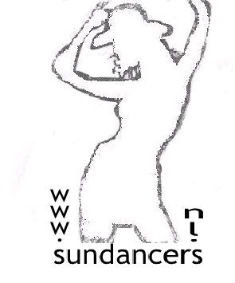

Hold My Hand

Choreographed by : Esmeralda v.d. Pol NL (Nov10)
Music : “Hold My Hand” by Michael Jackson & Akon
Descriptions : 48 counts- 2 wall- Intermediate level linedance
16 Counts Intro after the beat
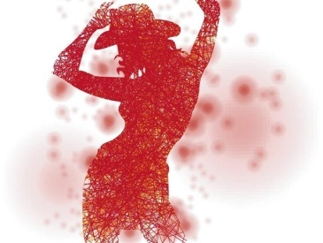
Side, Cross Rock Back, ¼ Turn R, Pivot ½ Turn R, Lock Step L , Lock Step R
1-2& Step left to the left side, Rock back on right, Recover on left
3-4& Make ¼ turn right-stepping right fwd, Step fwd on left, Make ½ Turn right
5-6-& Step fwd on left, Lock right behind left, Step fwd on Left
7&8 Step fwd on right, Lock left behind right, Step fwd on right.

Fwd Rock-recover, Lock Step Back, 2x ½ Turn R, R Coaster Step
1-2 Rock fwd on left, Recover on right
3&4 Step back on left, Lock step rights across left, Step back on left
5-6 Make ½ Turn right-stepping fwd on right, Make ½ turn right stepping back on left
7&8 Step back on right, Close left next to right, Step fwd on right

Lock Step Fwd, ¼ Turn L, Sailor ½ Turn Cross, Side Rock, Cross Shuffle
1-2& Step fwd on left, Lock right behind left, Step fwd on left
3 ¼ Turn left, stepping right to the right side
4&5 Make ½ Turn L-cross step left behind right, step right to the right side, Cross left over right
6& Rock right to the right side, Recover on left
7&8 Cross right over left, stepping left to the left side, Cross right over left

Side Rock, & Cross, Rock & Cross, Side, Shuffle ½ Turn Left
1-2 Rock left to the left side, Recover on right
&3 Close left next to right, Cross right over left
4&5 Rock left to the left side, Recover on right, Cross left over right
6 Stepping right to the right side
7&8 Make ½ turn left-step left the the left side, Close right next to left, Step left to the left side
(restart 2th and 4th wall)

Cross Rock Fwd, Side, Cross, Full Turn R, Rock & Cross, Coaster ¼ turn R
1-2& Cross rock fwd on right, Recover on left, Stepping right to the right side
3-4 Cross left over right, Full turn right (weight on LF)
5&6 Rock right to the right side, Recover on left, Cross right over left
7&8 Make ¼ turn right-stepping back on left, Step right next to left, Step fwd on left

Fwd Rock-recover, ½ turn Rock-recover, Back Rock-recover, ½ Turn L, ¼ Turn L, Cross Shuffle
1-2 Rock fwd on right, Recover on left
&3 Make ½ turn right-rock fwd, Recover on left
4& Rock back on right, Recover on left
5-6 Make ½ left turn-stepping back on right, ¼ turn left-stepping left to the left side
7&8 Cross right over left, Step left to the left side, Cross right over left

Restart during wall 2 and 4, dance up to count 8 of section 4, you need a extra & count to restart the dance, close right next to left, start again.

Special thanks to Joyce for the music

www.sundancers.nl / info@sundancers.nl / Esmeralda 06-38263580

